Iowa Partnerships for Success (IPFS)
Project Resources/Recommended Training for New Coordinators

Welcome to your new role as a coordinator for the Iowa Partnerships for Success project! This is an exciting grant opportunity designed to reduce underage and underage binge drinking. This project has set the bar high with an expectation to use an effective, data driven process to create change, and as you may have already realized, requires you to hit the ground running! Fortunately, with this expectation, comes a variety of guidance documents and training materials to assist you in the process. This list is designed to give you a solid foundation in the project goals and expectations, both from a state and local level, as well as an understanding of the Strategic Prevention Framework (SPF) process.

We suggest that you meet with your supervisor and Capacity Coach to review this list. They can assist you in locating needed documents and help you set a timeline for viewing and reading materials. We also suggest that you make time to meet with key coalition or Collaboration Council stakeholders to assist you in reviewing key documents, as well as give you context for how the project has been implemented so far.
We suggest that you read or view the following resources:

Big Picture Project Overview

Project acronyms and history
IPFS Orientation Presentation
IPFS Grant Checklist and Orientation Process
IPFS Request for Proposals (RFP)
Overview of the SPF (mini-training)
What is the SPF? An Introduction to SAMHSA’s Strategic Prevention Framework
Attend the Substance Abuse Prevention Skills Training (SAPST)
You can register here
IPFS Project Overview
Key Dates (refer to most recent version)
Quarterly Report Guidance
Iowa Capacity Coaching
Capacity Coach Overview

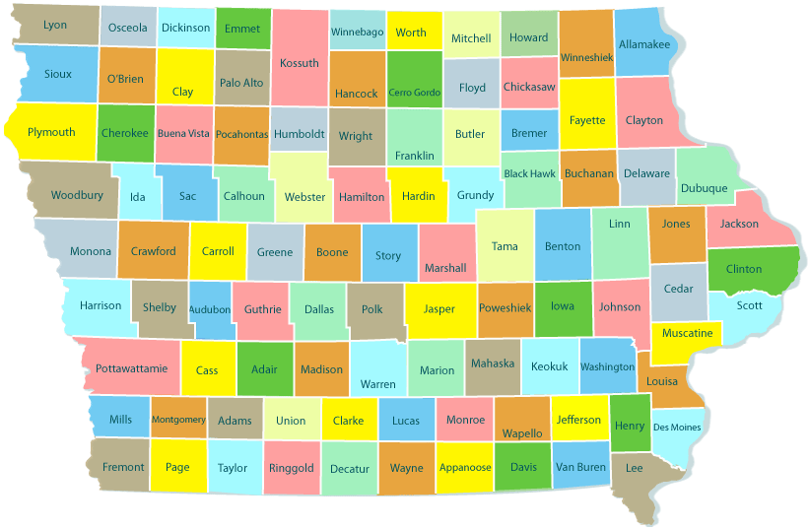
County Project Overview
All of these documents are available from your agency. Be sure that you have the most recent version as several of these documents are updated throughout the project. Please contact Julie Hibben at julie.hibben@idph.iowa.gov if you are having difficulty locating a specific resource.

Your agency’s RFP application
County Assessment Workbook
County Community Readiness results
County Capacity Workbook (be sure you have the most recent version)
County Strategic Plan (this includes your action plan)
County Evaluation Plan

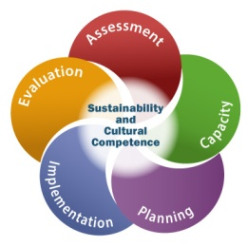

Applying the SPF

Assessment
Using Assessment to Plan for Success Mini-Training
CADCA Assessment Primer
Tri-Ethnic Center’s Community Readiness for Community Change

Capacity
Capacity Building Mini-Training
CADCA Capacity Primer

Planning
Planning for Success: Creating An Action Plan Mini-training
Choosing Strategies For Community Change Mini-training
CADCA Planning Primer
EBP Selection Workbook
Implementation
CADCA Implementation Primer
IPFS Implementation Guide
Project resources related to the strategies your county is implementing

Evaluation
Evaluation Mini-Training
Evaluation Primer and Guide
CADCA Evaluation Primer

Cultural Competence
CADCA Cultural Competence Primer
Disparate Population Guidance for Counties
Cultural Competence
Elements of a Culturally Competent Prevention System
Resources for Incorporating CLAS Standards
Skills for Cultural Competence
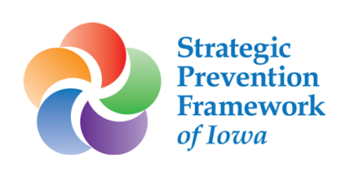

Additional Project Information

National Cross Site Evaluation/Community-Level Instrument Revised (CLI-R)
This SAMHSA required data collection process occurs on a yearly basis through the Prevention Management Reporting and Training System (MRT). There will be an updated guidance document provided to Coordinators before each CLI-R is due. The due dates for the CLI-R can be found in the “Key Dates” document listed above. The surveys and past guidance documents can be found here.

Community Check Box System (CCB)
IDPH uses the CCB system to collect process data related to strategy implementation. Only services connected to the yearly updated Action Plan should be entered into the CCB. Coordinators should aim to enter at 20 or more entries each reporting month. Click here to learn more about CCB.

CCB Overview Webinar
Master Code Book
Participant Demographic Information Cheat Sheet
CCB Data Entry Review Process
Exporting Data from the CCB
CCB Frequently Asked Questions Document

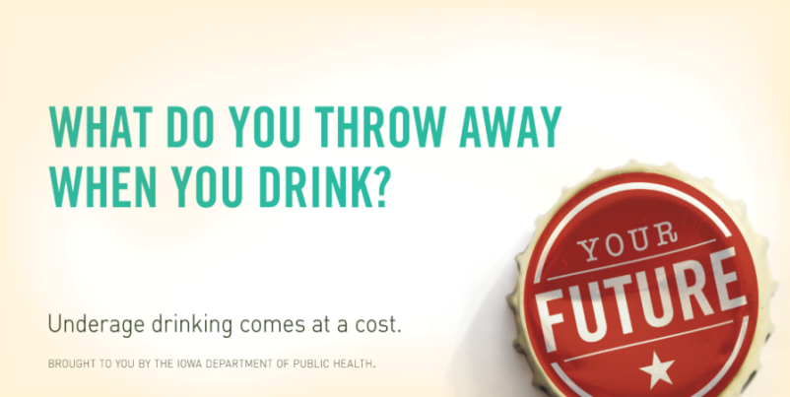

IPFS Media Campaign

IPFS What Do You Throw Away Media Campaign Webinar PPT
Media Campaigns Press Release Template
Menu of Creative Materials

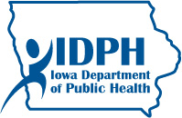
Collaboration with Suicide Prevention
IPFS funded counties are required to provide suicide prevention services during each year of the project.

FY17 Iowa Partnerships for Success Suicide Prevention Services
Review the additional IPFS suicide prevention resources

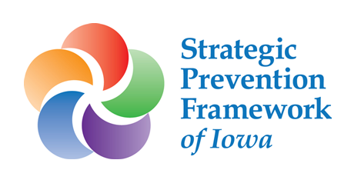
Iowa Youth Survey
IPFS funded counties are required to provide services to the Iowa Youth Survey during each year of the project.

FY17 Iowa Partnerships for Success Iowa Youth Survey Services

Please keep in mind that this is not an exhaustive list of all of the resources available to you. We encourage you to continue to read and explore other available resources (including those available here and here), talk with other coordinators, and seek assistance from your agency and project staff as you continue to “trust the process” and put SPF to work in your community.

